Cognos 8 Transformer

Lab Guide

Table of Contents

Lab 01: Creation of a model 3
Lab 02: Verify Your Model 9
Lab 03: Create a Time Dimension Manually 10
Lab 04: To create a Calculated Measure 14
Lab 05: Creation of a Measure Folder 17
Lab 06: Roll- Up Options 18
Lab 07: Create a Alternate Drill-down path 20
Lab 08: Create a Cube Group 22
Lab 09: Create Incremental Powerplay Cube 24
Lab 10: Security settings 25
Lab 11: Publishing PowerCube to Cognos Connection 31

Lab 01: Creation of a model

- Objective :

Creation of a model

- Steps:
- From the File menu, click New to open the New Model wizard.
- Type a name as “labguide” for your new model and click Next.

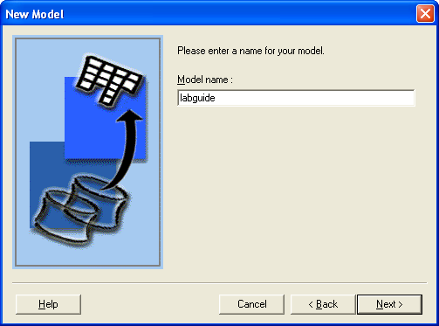

- In the Data source Type box select “Cognos Package”.
Tip: If you want the data source name to default to the name of the package or report that you select in the next step, leave the Data source name box blank.
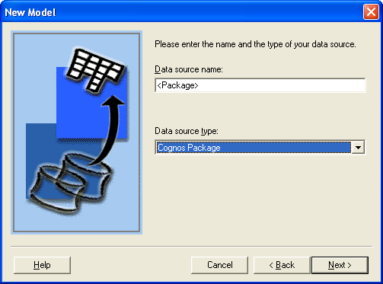

- Click Browse to open the metadata browser and select a package as “Go Sales” from the available list.
- Click Next.
- In the Query Name box, type a name for the new query. Leave it as it is as default.
- In the Source list, select the query items Closing Inventory (Measure), Time dimension, Product dimension to import and click Add to add the selected query items to the Transformer query.
Note: If the data source is a report and the report contains multiple queries as in the case of some Report Studio authored reports, each query will be shown with its relevant query items.
- Click OK.
- Uncheck the Run Auto Design check box.
Note: If you want Transformer to automatically create a preliminary dimensional structure for you, on the last page of the wizard, select the Run Auto Design check box.
- Click Finish.

Creation of a New model

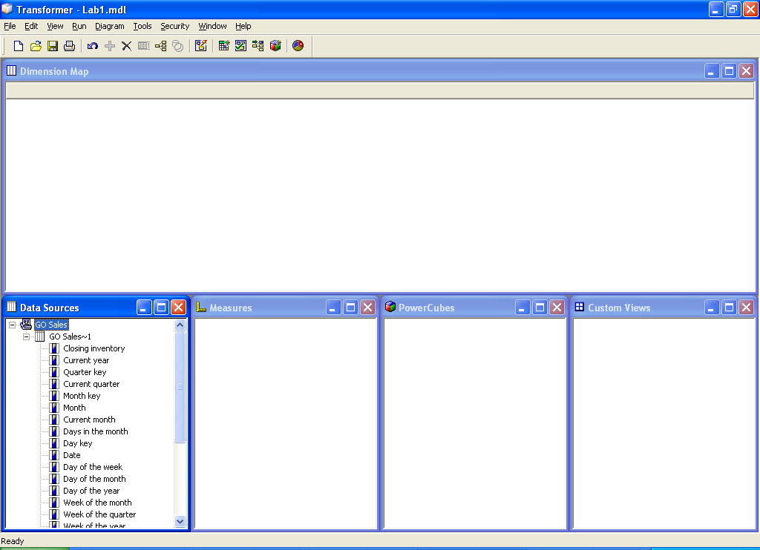

Refer to Lab1.mdl

    - Right click on Dimension map tab and select Insert Dimension to create Dimensions.

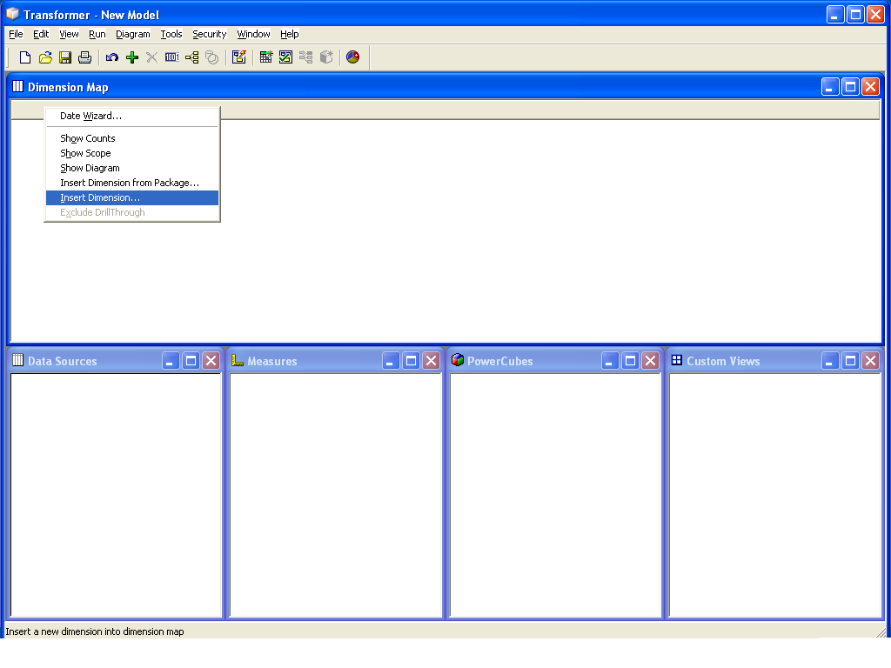
2. Specify name for dimension as “Product” and Dimension Type is Regular for non Time dimensions.
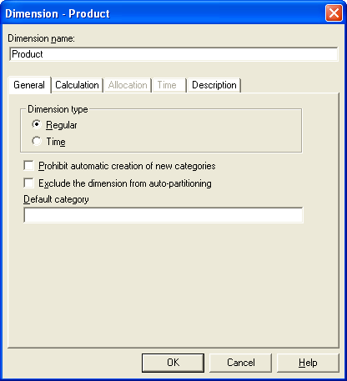

- Click Ok.
- Drag the data Items (query Items) Product Line, Product Type, Product Name as the levels in our Product Dimension from the Data Sources window.
- Right click on Dimension map tab and Insert Dimension named “Time”
- Specify a name for the dimension as “Time” and Dimension Type is Time.
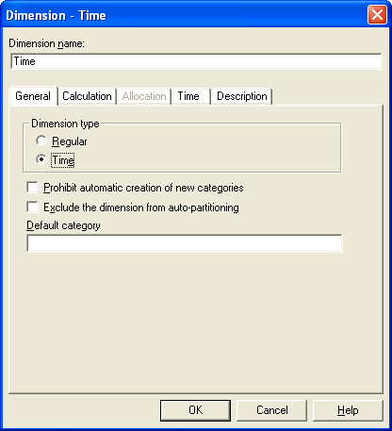

- Drag the data Items (query Items) Current Year, Current Quarter, Current Month as the levels in Time Dimension from the Data Sources window.
- Drag the measure Closing Inventory to Measures Window.

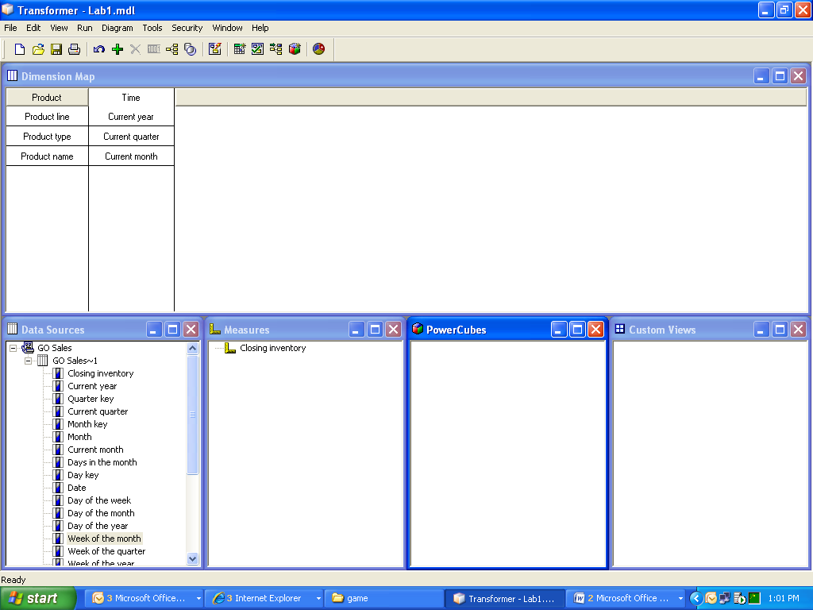

Refer to Lab2.mdl

Lab 02: Verify Your Model

- Objective :
Transformer provides a built-in validation tool to help you identify problems with your model design. We recommend that you run this tool after each major step in the model design process, to check for potential problems.
- Steps:

- From the Tools menu, click Check Model

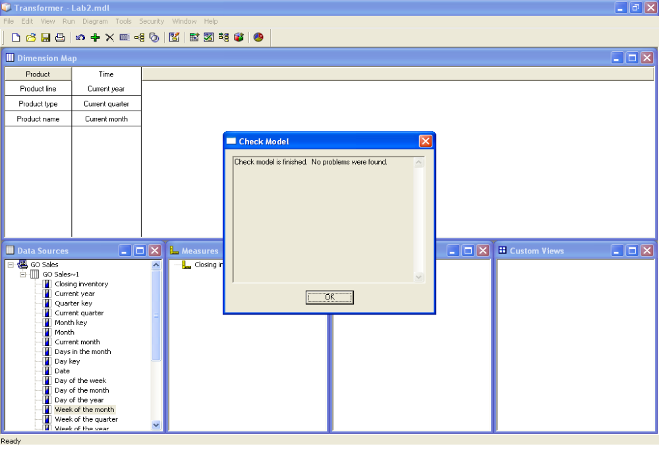

Lab 03: Create a Time Dimension Manually

- Objective :

You can create your time dimension manually to meet the particular needs of users.

Steps:

- From the Edit menu, click Insert Dimension
- In the Dimension name box, type a name for the dimension as “Calendar Date”.
- In the Dimension type box, select Time.
- Click the Time tab.
- In the Date Level Creation dialog box, select Create standard levels (Year/Quarter/Month) to allow Transformer to automatically specify the required date structure.
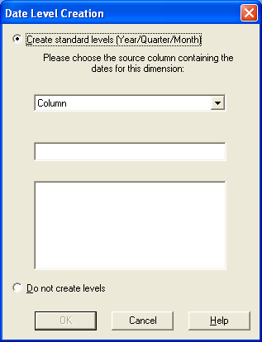

- In the Source column list, select the column “Date” that contains values for the dates in the dimension and click OK twice. Transformer creates the new time dimension, adding the standard levels Year, Quarter, and Month.

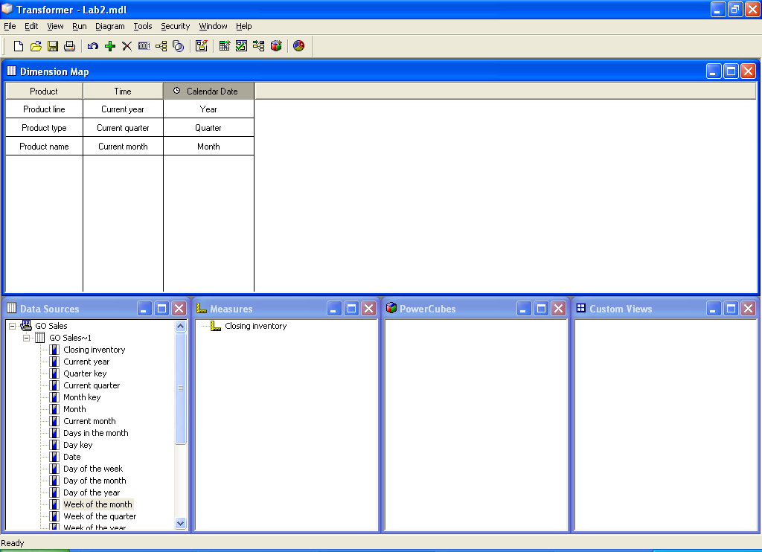

Refer to Lab 3.mdl

- If you want to add a new level, drag the source column “Week” for the time dimension from the Data Sources list to the new time dimension Calendar Date.
- Open the property sheet for this new level.
- In the Level Name Box, type a name that reflects the date function you plan to apply to this level, such as Week.
- Click the Time tab.
- In the Date function box, select the function “week” to apply to this level and click OK.

Note: You can now change any of the following properties, which are usually set automatically when you create the time dimension for your model:
- The Associations for the time dimension
Set this property on the Source tab of the Level property sheets.
- Whether to always include all date categories, or only those for which source values exist, when calculating relative time categories

Set this property in the Inclusion box on the General tab of the Level and Category property sheets.
- The date function for each time level in the model, such as Year, Quarter, and Month
Set this property on the Time tab of the Level property sheet.
- The format used for date values shown in the category viewer
Set this property on the Time tab of the Level property sheet.
- The column used to order the categories in each date level
Set this property on the Order By tab of the Level property sheet.

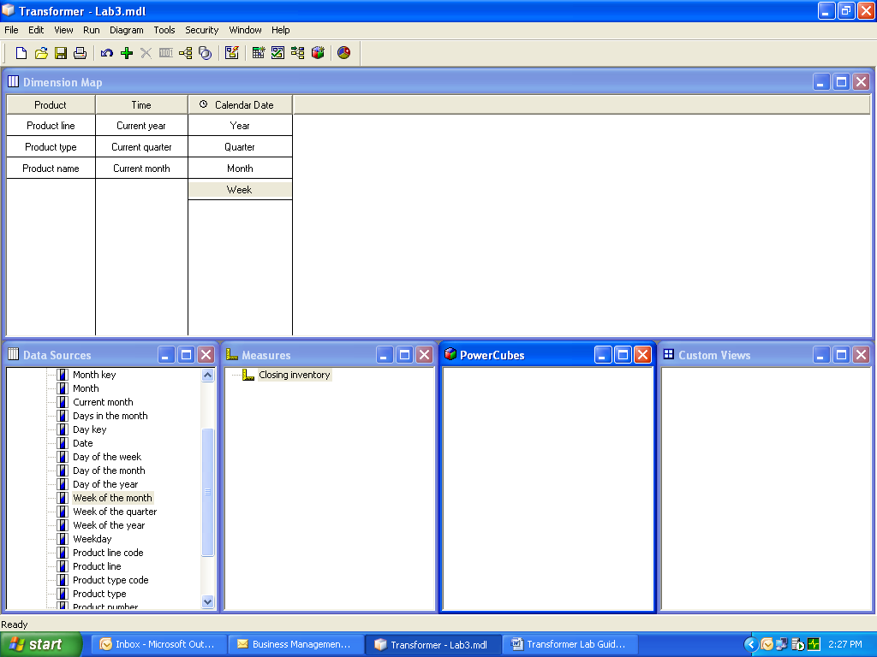

Refer to Lab 4.mdl

Lab 04: To create a Calculated Measure

- Objective :

You can create a calculated measure to derive new numeric data from regular measures, other calculated measures, functions, and constants.

- Steps:

- Click the Measures list to make it active and, from the Edit menu, click Insert Measure.
- In the Measure name box, enter a name for the measure as “Cal Masure1”.

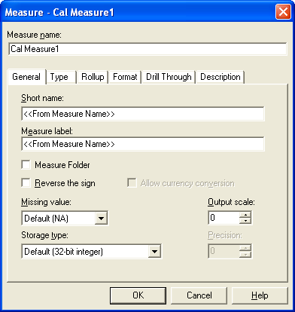

- The measure name must be unique in the model.
- Select the Type tab, click Calculated and then click Calculation.
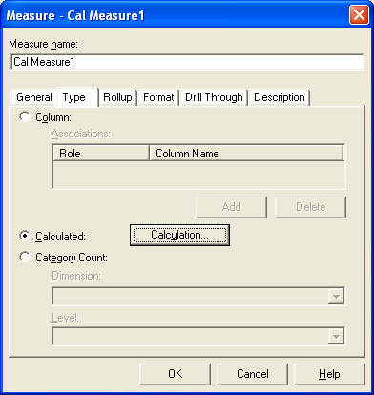

- In the left pane of the expression editor, expand the Functions and Measures folders as needed, select each parameter you want to use and click the arrow to insert it into the calculation expression (right pane of the editor).
- Select the Measure “Closing Inventory” Click the Arrow to add and select the symbol “+”Click the Arrow to add and Select a number parameter from the left side pane to add a number 100 or type the number 100 directly from the Key board.
- When the expression (Closing Inventory + 100) is complete, click OK.
- Type or select the other features you want for the measure, such as the description and format and click OK.
- Your new calculated measure appears in the Measures list.
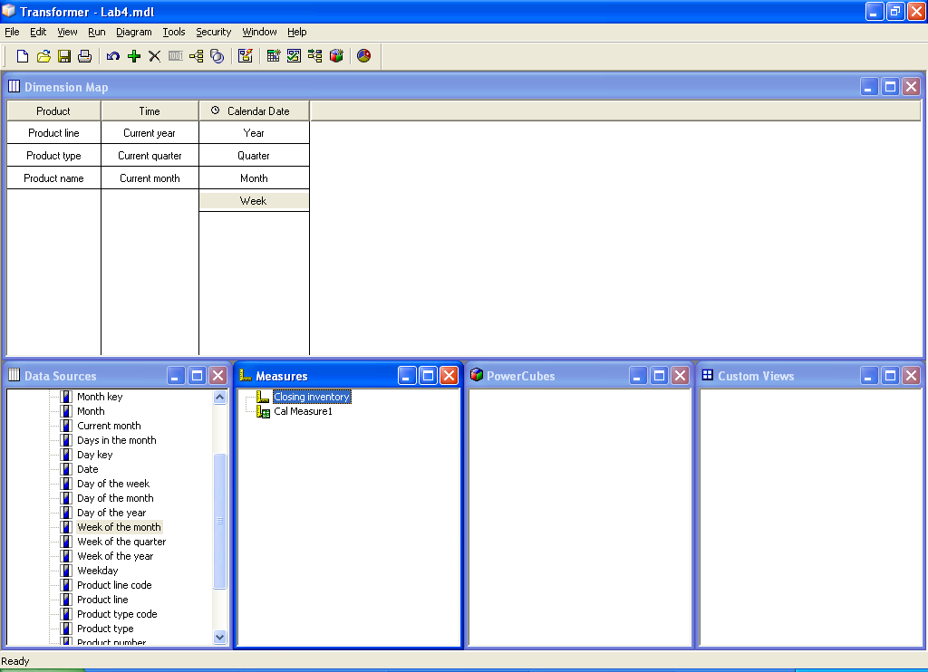

Refer to Lab 5.mdl

Lab 05: Creation of a Measure Folder

- Objective :

Measure folders can represent logical groupings of lower-level measures, or they can be calculated measures without any lower-level measures.

- Steps:

- Right-click the Measures pane and click Insert Measure Folder
- In the Measure name box, type a name for the measure folder as “Measure Folder”.

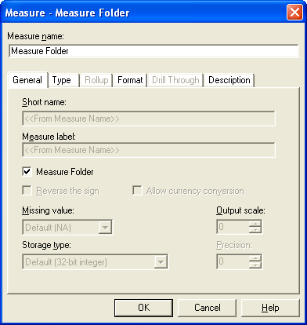

- The measure name must be unique in the model. By default, the measure name is derived from the original name of the associated source column and the Short name and Measure label options are set to <<From Measure Name>>.
- Drag existing measures Cal2 (Closing Inventory/5), Cal Measure1 (Closing Inventory+100) into your new measure folder.

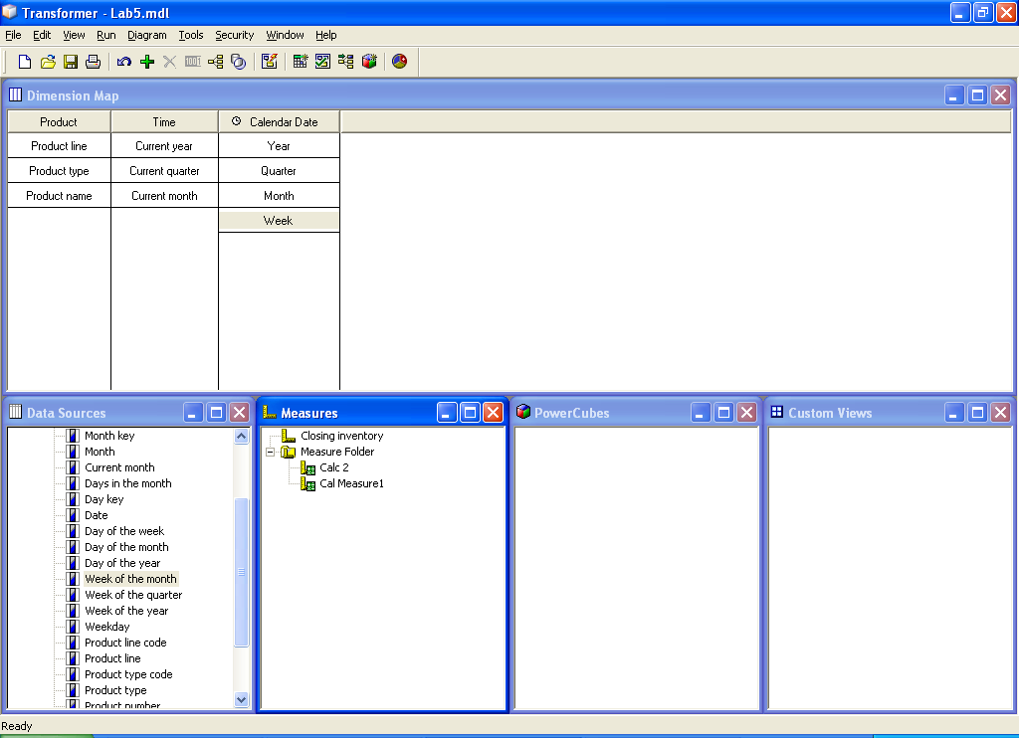

Refer to Lab6.mdl

Lab 06: Roll- Up Options

- Objective :

Defining the Roll-Up options

- Steps:

- Open the property sheet for the calculated measure and click the Rollup tab.
- In the Regular timing box, click Before Rollup or After Rollup and click OK.

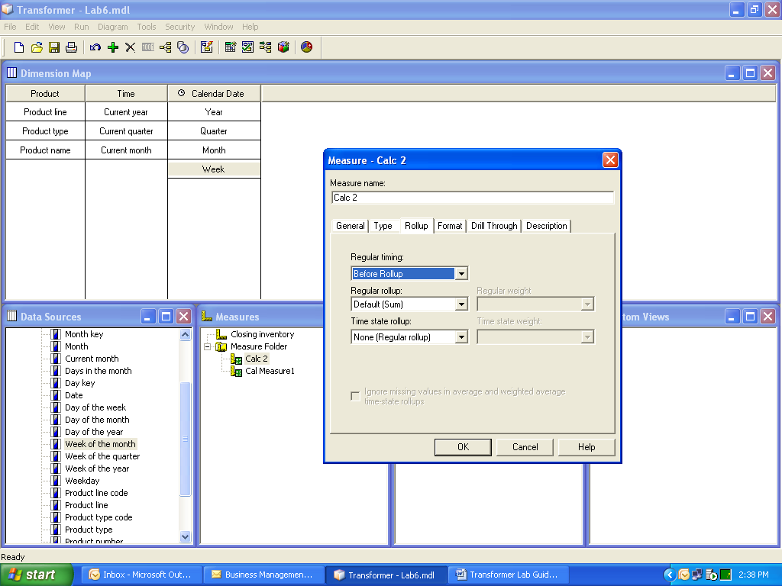

Refer to Lab7.mdl

Lab 07: Create a Alternate Drill-down path

- Objective :

You set up an alternate drill-down structure in a dimension to provide a different perspective on the data. Each alternate path connects to the primary path at the convergence level.

Steps:

- In the dimension map, select the level “Product Line” that is to be the convergence level for the new alternate drill-down path and, from the Edit menu, click Create Drill-Down. So that You can Have two Drill down paths namely:
Product Line-> Product Type -> Product Name
Product Type -> Product Name
Note: Drag a column to the dimension map at the level where you want to add a new level as the alternative Drill down path.
- If appropriate, add intermediate (manual) levels to the new drill-down path.
- To ensure you have not introduced uniqueness problems, from the Tools menu, click Check Model.

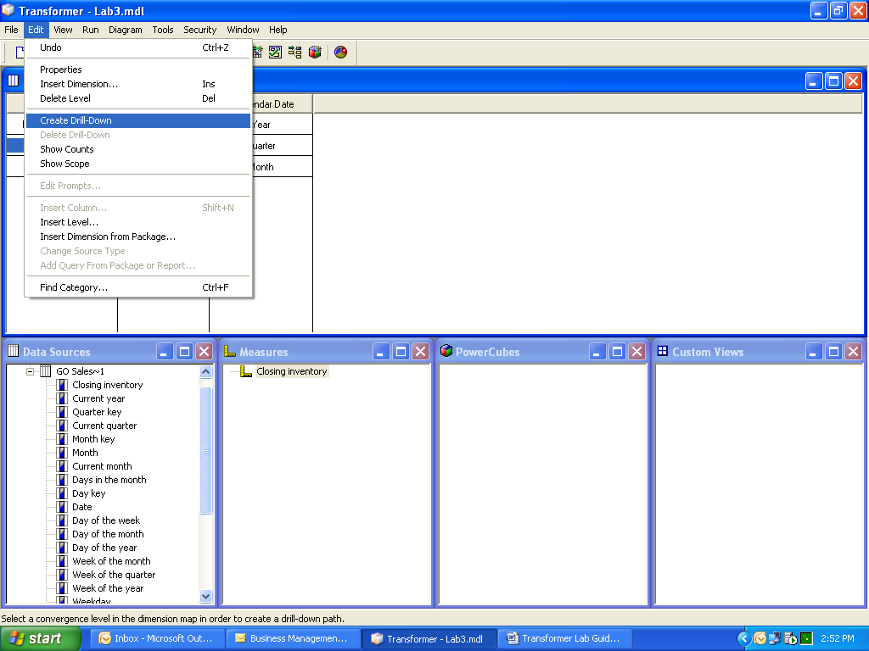

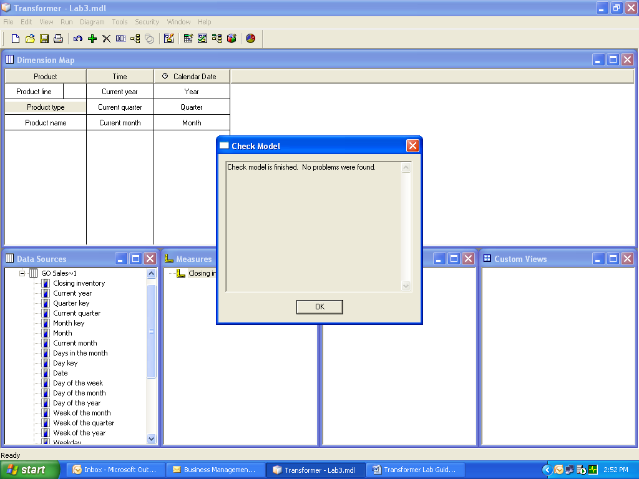

Refer to Lab8.mdl

Lab 08: Create a Cube Group

- Objective :
You can create a cube group for any level in a dimension and add child cubes that include selected categories or measures. For each cube in a group, you must specify the degree of detail to be included so that your users see only the most relevant data.
- Steps:

- Click in the PowerCubes list to make it active and, from the Edit menu, click Insert Power Cube.
- In the Power Cube name box, type a name for the new Power Cube group as “Cube Group”.
- Click the Cube Group tab.
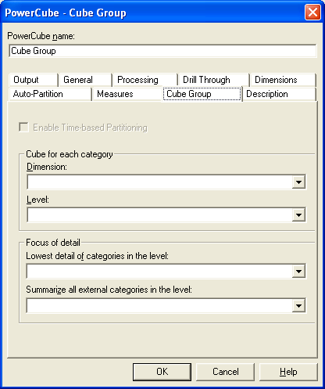
s
- In the Dimension box, select the dimension “Product” from which you want to build the cube group.
- In the Level box, select the level “Product Line” whose categories will become the individual cubes in the cube group.
- When you have finished setting the required properties on each of the other tabs, click OK.

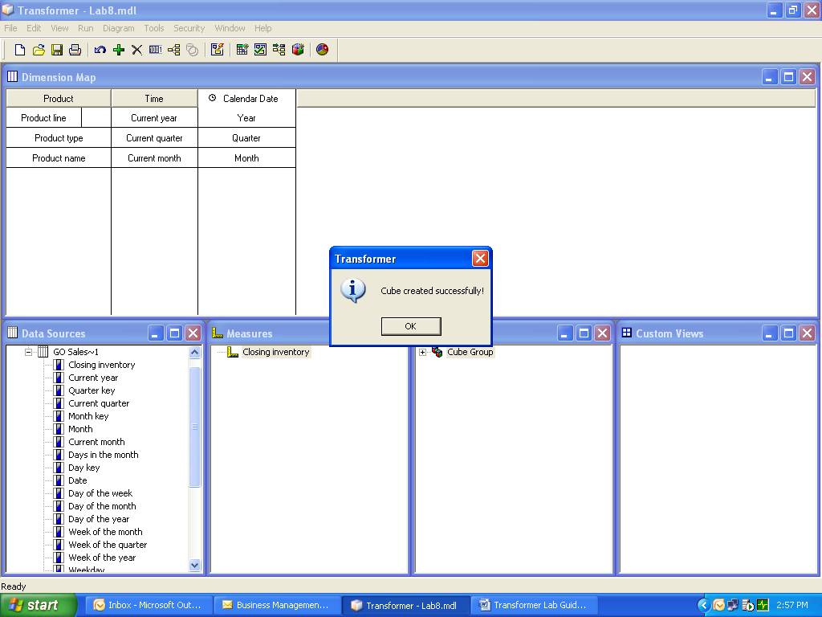

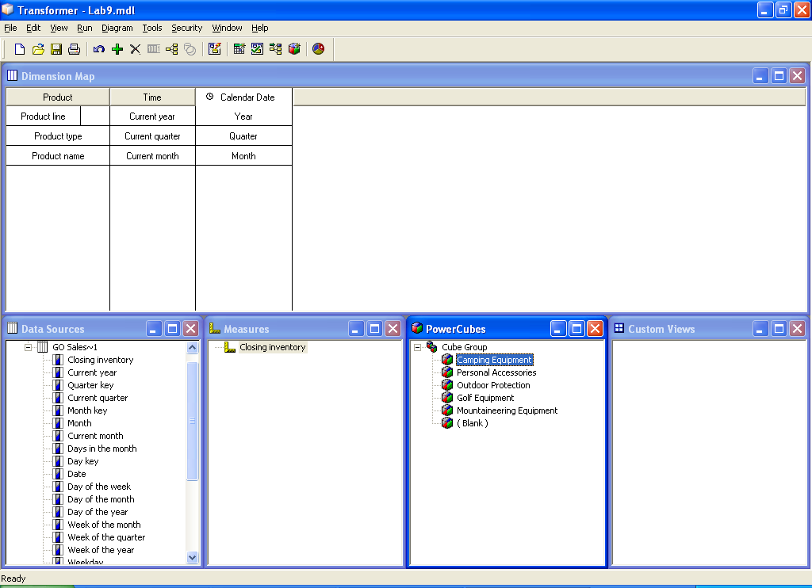

Refer to Lab 9.mdl

Lab 09: Create Incremental Powerplay Cube

- Objective :

It is best to place frequently updated data in one or more separate data sources, so that you can perform incremental updates to quickly add the latest changes to your existing cube.

- Steps:

- Add a new cube definition cube1 to the PowerCubes list.
- Open the property sheet for the cube1 and click the Processing tab.
- Select This cube is incrementally updated check box and click OK.
- Create the cube.

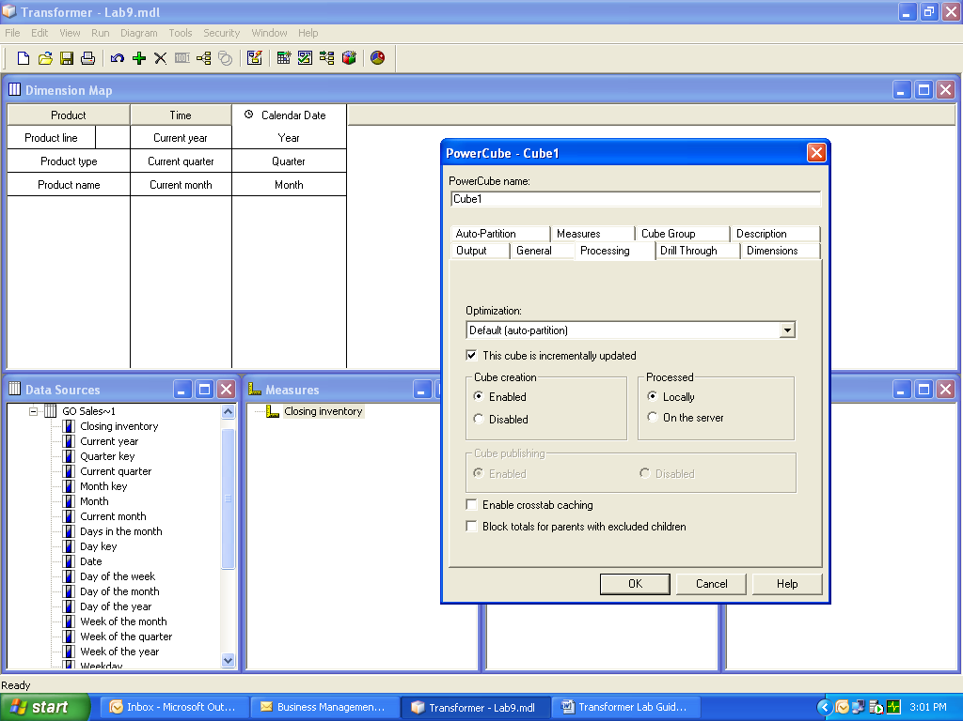

Refer toLab10.mdl

Lab 10: Security settings

- Objective :

Implementation of Security within the built cube

- Steps:

- Open a model in Transformer and, from the Security menu, click Log On As.
- In the Logon dialog box, select the appropriate namespace and log on as an authenticated user.
- Open the Transformer diagram for your model and click the Custom Views tab.
- Right-click the Custom Views pane and click Create Custom View.
- In the Custom view name box, type a name for the custom view as “Cube_Security”.
- If you are not logged on to the namespace from which you want to assign members, click Log On, select the namespace, and then log on as an authenticated user for that namespace.
- In the Custom View dialog box, click Assign Security, and then do the following:

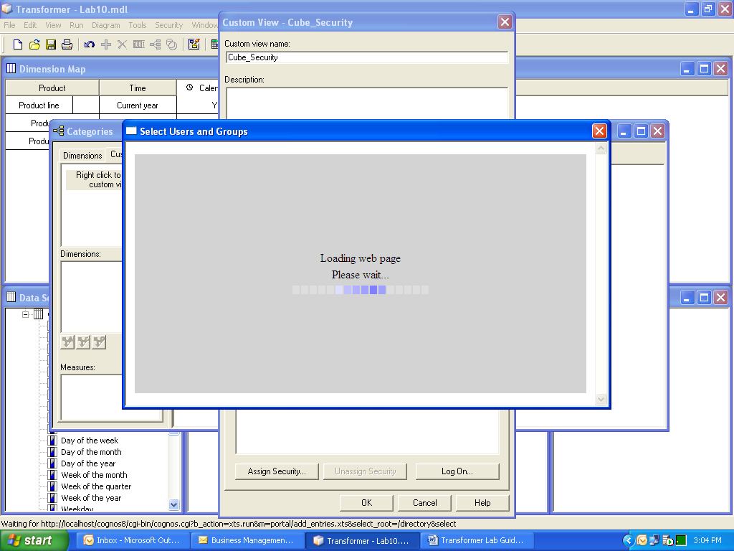

- In the Select Users and Groups dialog box, click the appropriate namespace to expand the available group and role entries.(Here it is SATYAM Namespace).
Tip: To select individual users in the list, click the Show users in the list check box.
- From the Available entries list, select the security objects (roles, groups, and users) to be assigned membership in the custom view and click the right-arrow button.
- When the entries you want appear in the selected entries box, click OK.

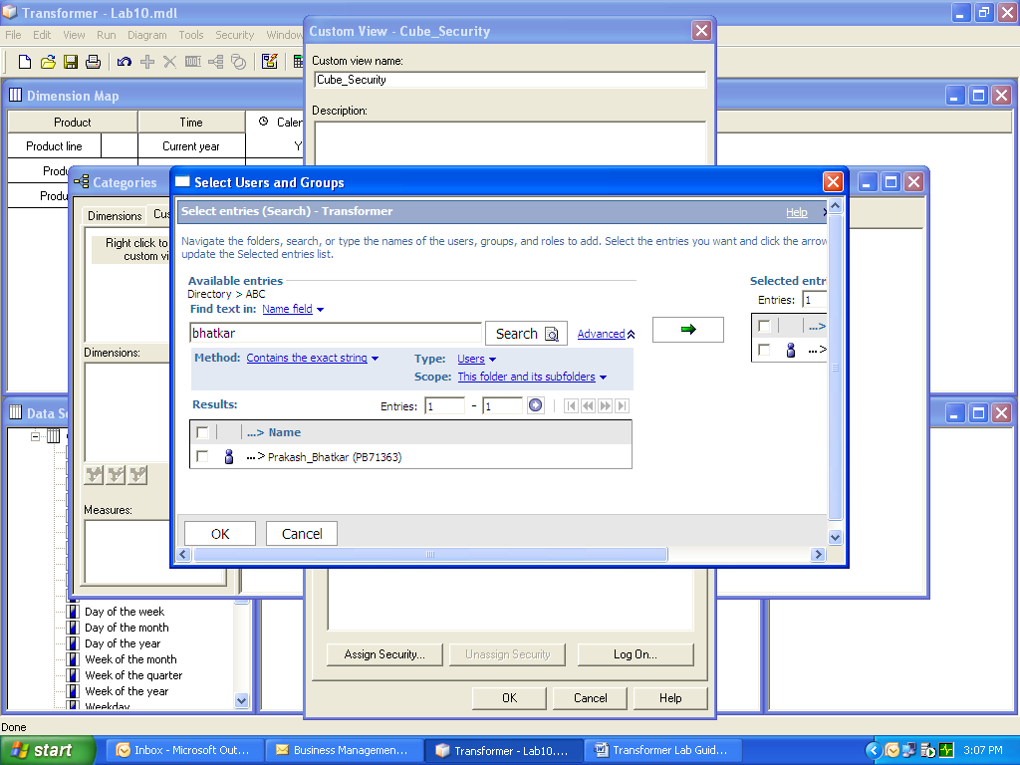

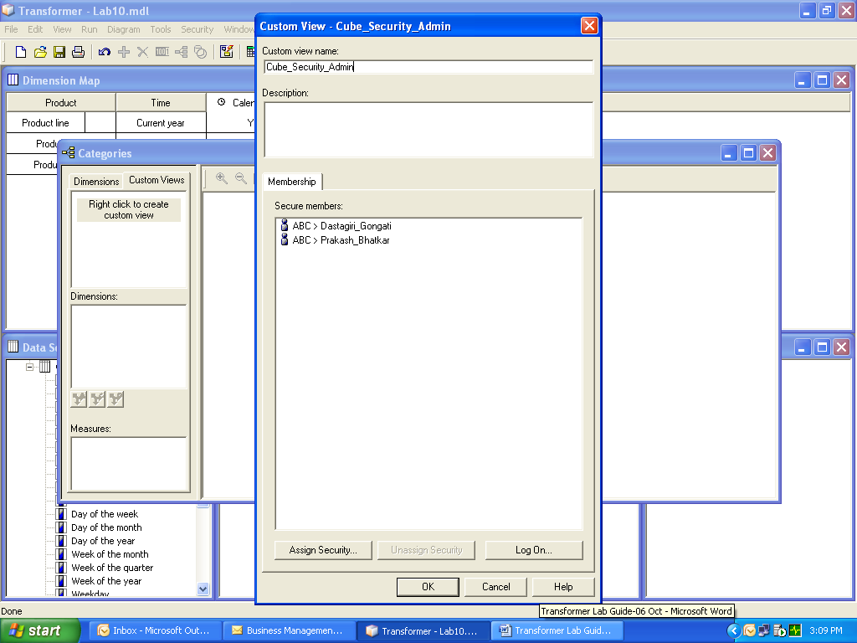

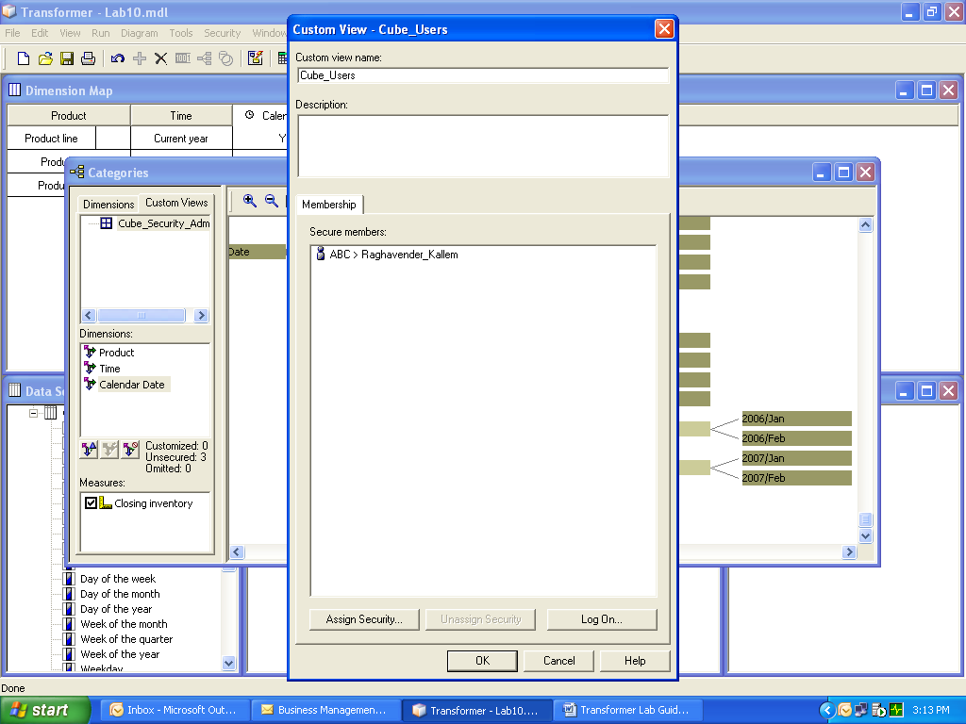

- The new custom view appears in the custom view list, the model dimensions appear in the Dimensions list, and the measures appear in the Measures list.
- To omit the dimension from the custom view, select the dimension and then click the omit button.
- To exclude a measure from the custom view, in the Measures list, clear the measure check box.
- In the Custom Views list, select the new custom view.
- In the Dimensions list, select a dimension.
- To create a custom view using the view operations Exclude, Cloak, Suppress, Apex, and Summarize.
- Click the customize button.
- In the category viewer, right-click the categories and apply the view operations (Exclude, Cloak, Suppress, Apex, and Summarize) until you achieve the desired effect.
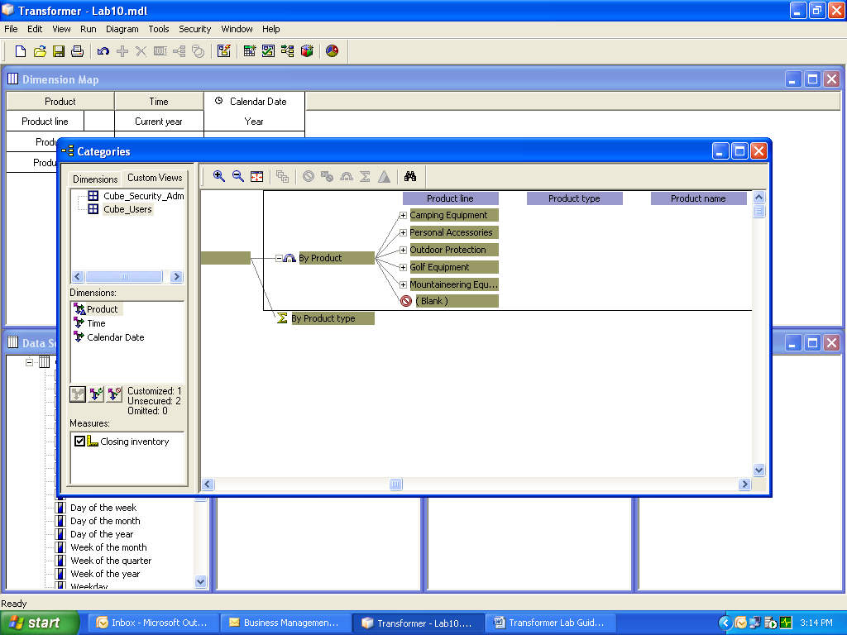

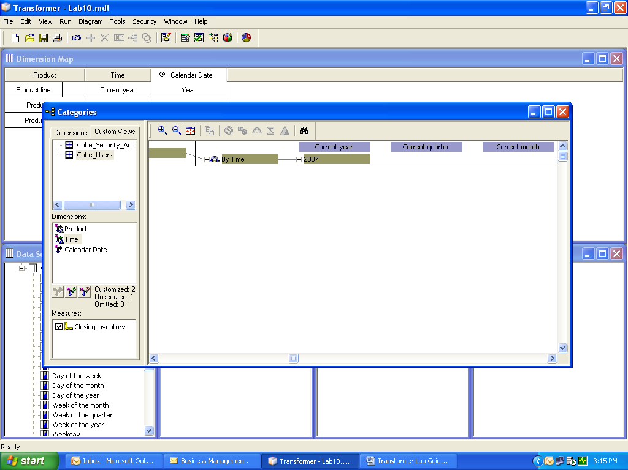

- When you are finished applying view operations to the custom view, close the category viewer and then, from the Custom Views list, drag the custom view that you want to associate to the cube to the appropriate cube or cube group in the PowerCubes list.

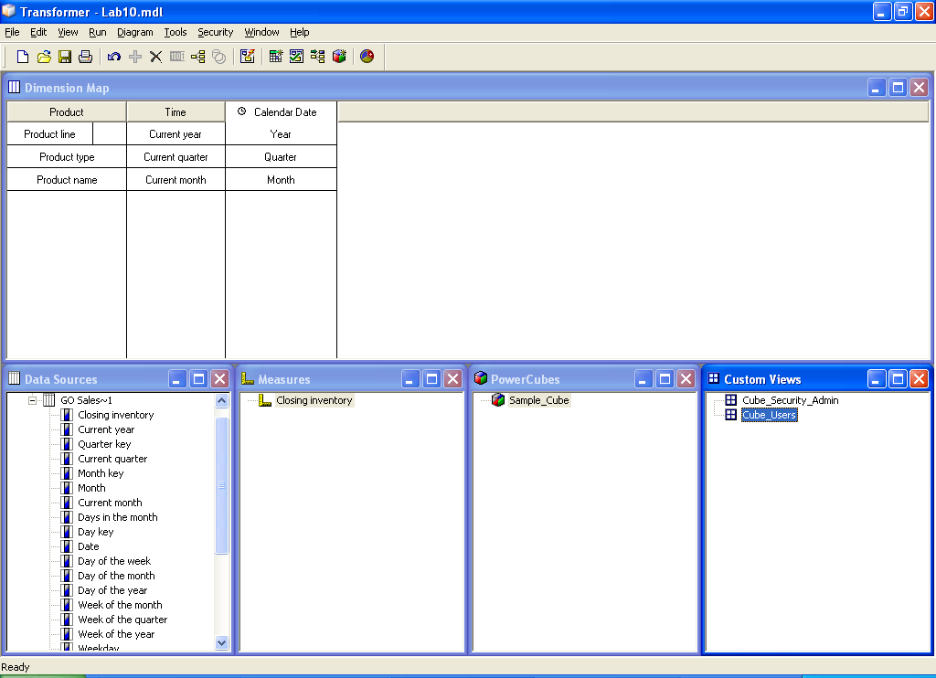

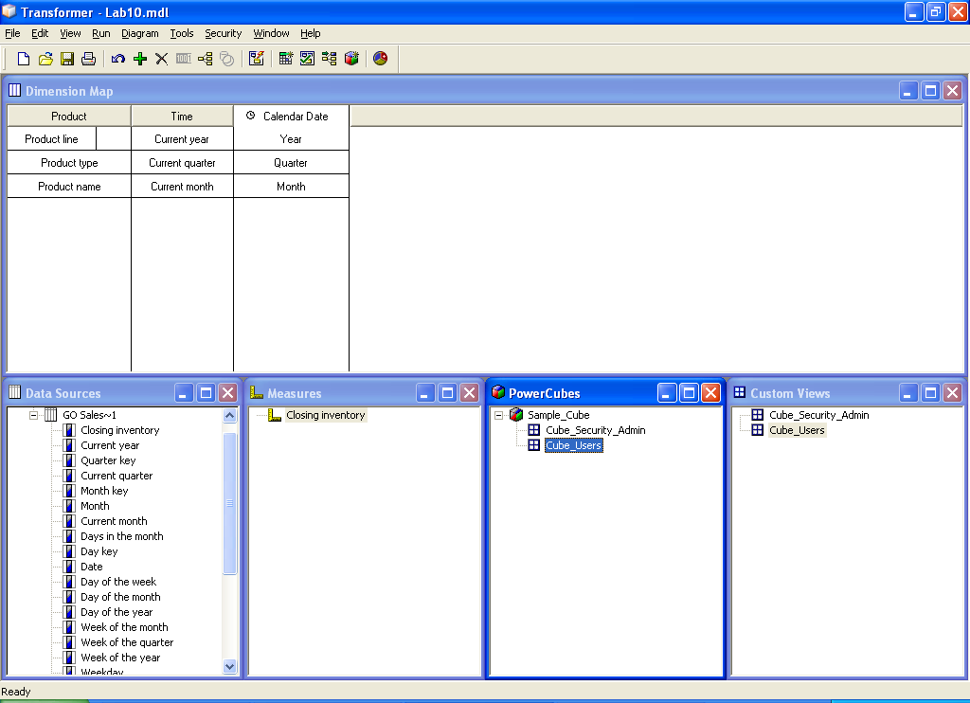

- Right click the Power Cube created and select the “Update selected Power cube” to update the power cube with the Custom views, Drill through etc.

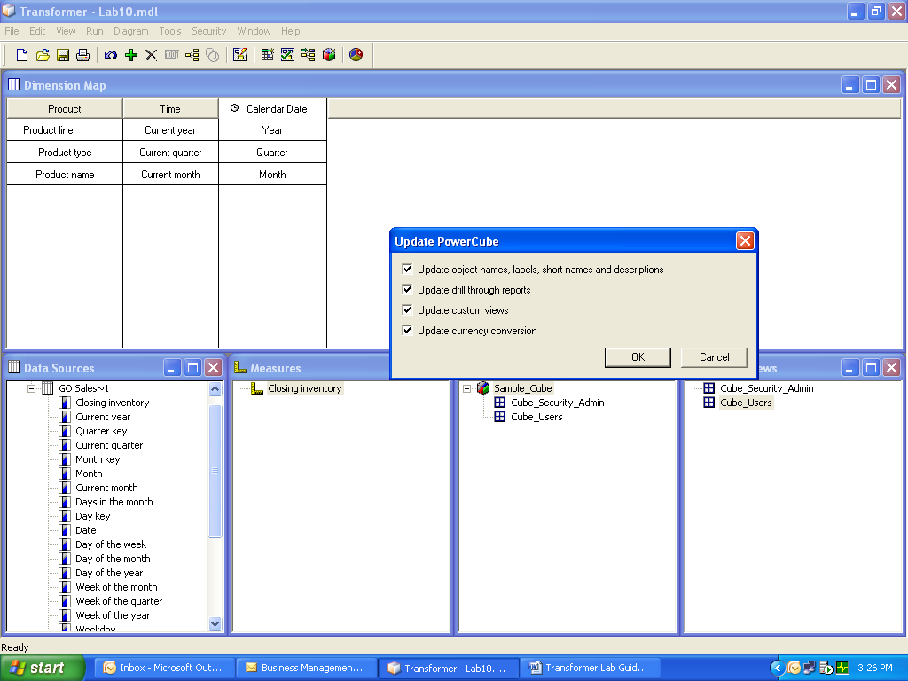

Refer to Lab11.mdl

Lab 11: Publishing PowerCube to Cognos Connection

- Objective :

Publishing the cube created in Transformer to Cognos Connection.

- Steps:

- Right Click on the cube we want to publish and click on the “Publish Power Cube as Data Source and Package”

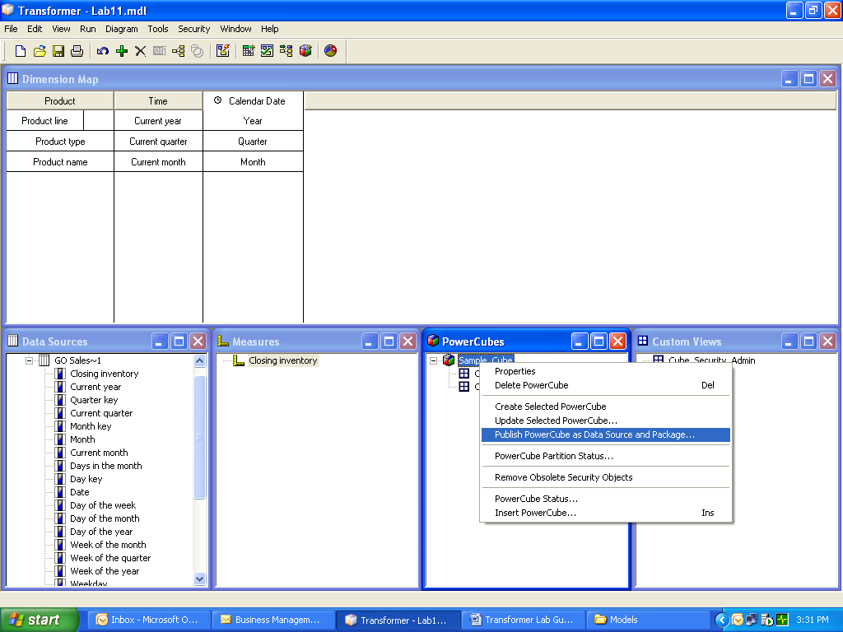

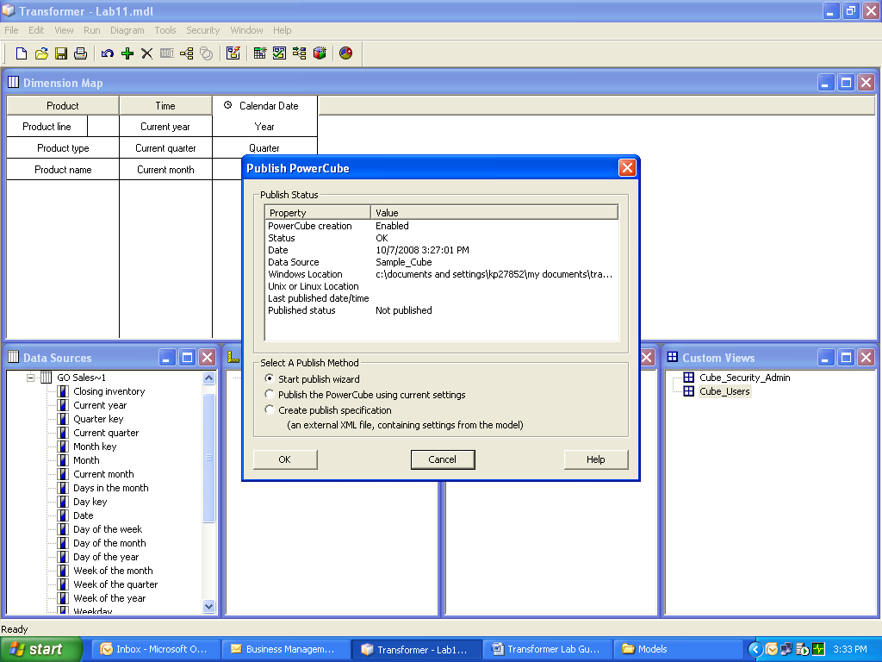

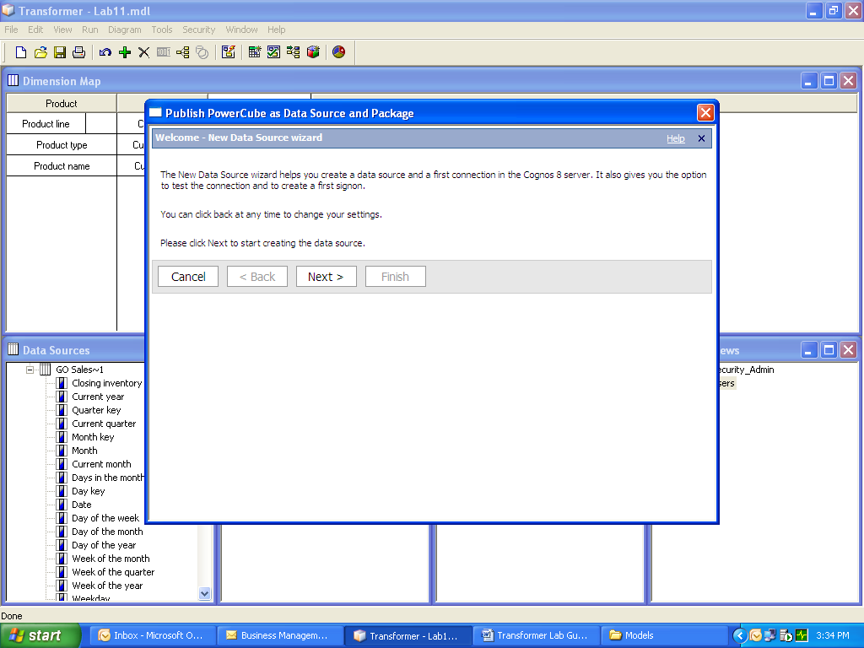
- Click on “Next”
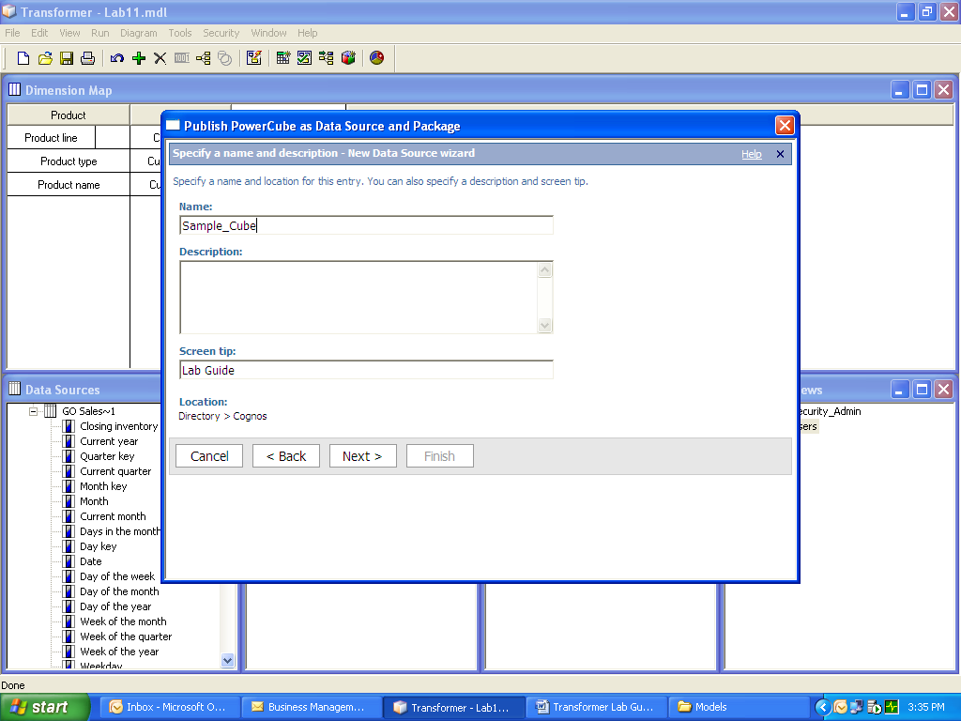
- Specify a name for Data Source Sample_ Cube and Click “Next”

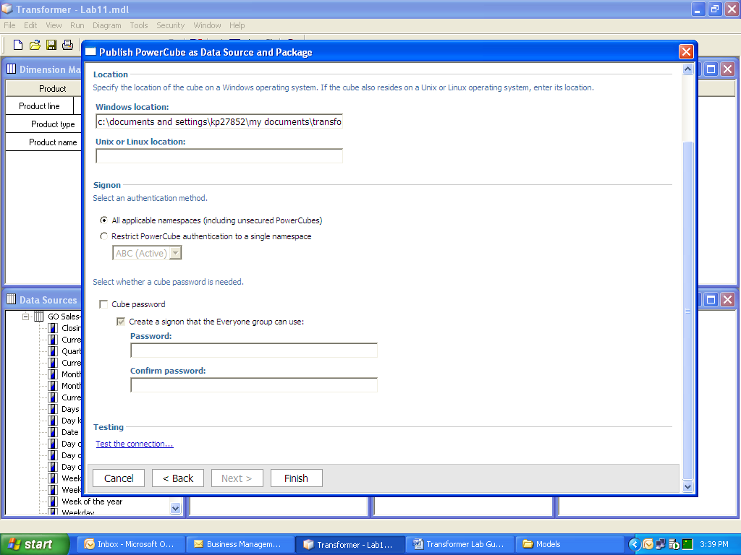
- Click on Finish.
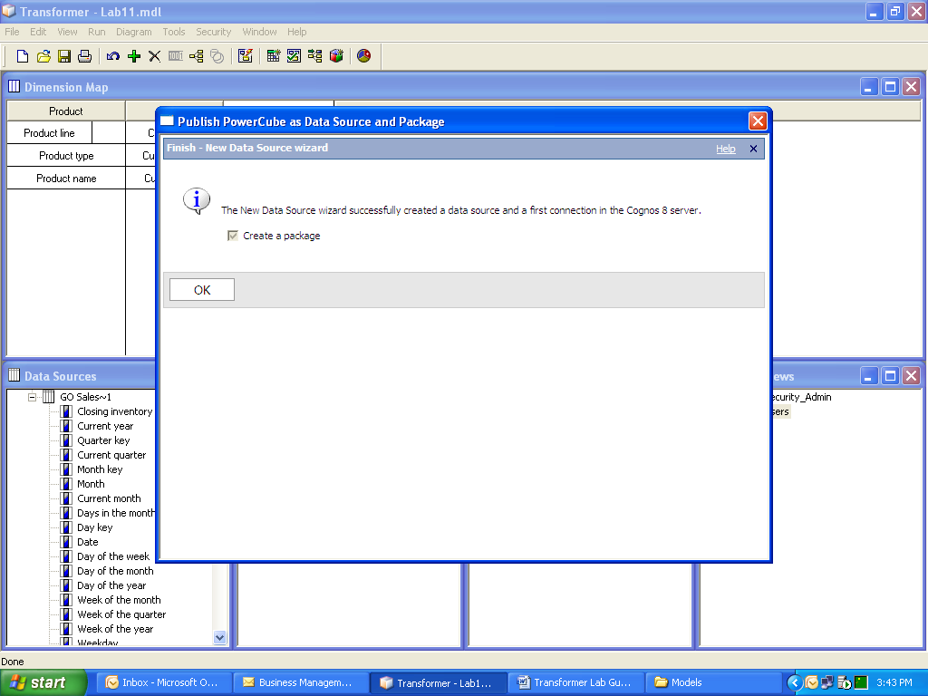
- Click “OK”.

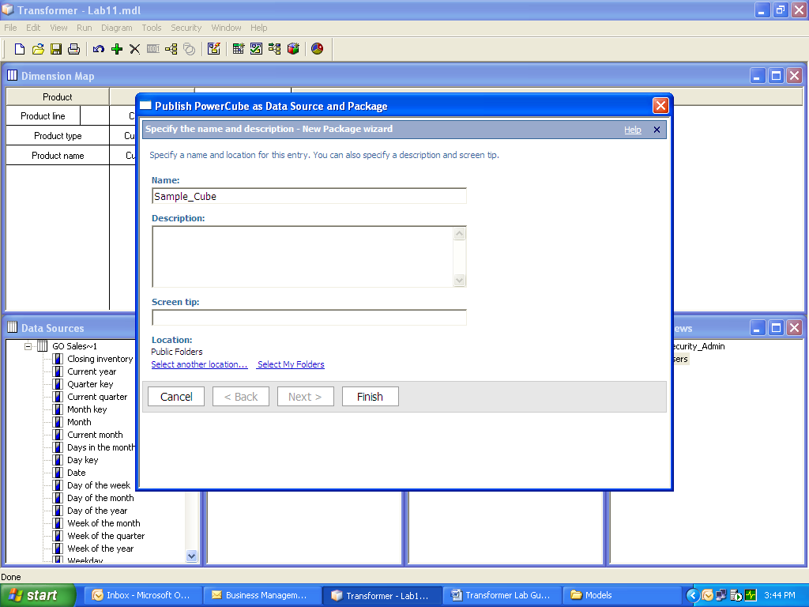

- Specify Name “Sample Cube1” and Location (Public Folders) of the package to be created in Cognos Connection and click “Finish”.
